ARAFE RF Attenuator Pin Connectivity

Look at three outputs on the RFSA3713 Step Attenuator:

* Pin 12 (LE = Latch Enable)
* Pin 13 (CLK = Clock)
* Pin 14 (S1 = Serial Data Input)

Pin Mapping

|  |  |  |
| --- | --- | --- |
| **Attenuator** | **Through-Hole** | **Microcontroller** |
| Pin 12/LE (SATT0) | JX-6 | Pin 19 (SATT0_CS) |
| Pin 12/LE (TATT0) | JX-12 | Pin 18 (TATT0_CS) |
| Pin 13/CLK (SATT & TATT) | JX-7 (SATT) and JX-13 (TATT) | Pin 27 (SPI_CLK) |
| Pin 14/SI (SATT & TATT) | JX-5 (SATT) and JX-11 (TATT) | Pin 26 (SPI_DATA) |

Elucidated further in the “connectivity” section

Connectivity in the Signal Chain

* Consulting the schematic of the red board (page 4), for the connectivity of the RFSA3713 (attenuator) to the MSP430G2153 (microcontroller) for both the sampling side (SATT0) and for the triggering side (TATT0) of the RF chain
* There are two attenuators
  + The first attenuates the entire signal chain (SATT0) and happens first
  + The second attenuates just the trigger chain (TATT0) after it has been split off by the coupler (DBTC-10-13LX+)
* The signal chain
  + SATT0_D/TATT0_D on the RF board
    - This the *data* which is why it is connected to pin 14/ SI on the attenuator
    - On the RF board, is connected to pin 14/SI of the attenuator
    - On the PC board, is connected to JX-5 (SATT)/JX-11 (TATT) (the through-hole pins, where x stands for any of the four on the board), which is SPI_DATA (pin 26) from the Microcontroller
  + SATT0_CLK/TATT0_CLK on the RF board
    - This is the *clock* which is why it is connected to pin 13/CLK on the attenuator
    - On the RF board, is connected to pin 13/CLK of the attenuator
    - On the PC board, is connected to JX-7 (SATT)/JX-13 (TATT), which is SPI_CLK (pin 27) from the Microcontroller
  + SATT0_CS is the on the RF board
    - The is the *chip select* from the microcontroller and is hooked to pin 12/LE on the attenuator
    - On the RF board, is connected to pin 12/LE on the attenuator
    - On the PC board, is connected to JX-6, which is SATT-~~CS0~~ (pin 19) on the microcontroller
  + TATT0_CS is the on the RF board
    - The is the *chip select* from the microcontroller and is hooked to pin 12/LE on the attenuator
    - On the RF board, is connected to pin 12/LE on the attenuator
    - On the PC board, is connected to JX-12, which is TATT-~~CS0~~ (pin 18) on the microcontroller

Diagrams

* Attenuator connectivity (PC schematic)

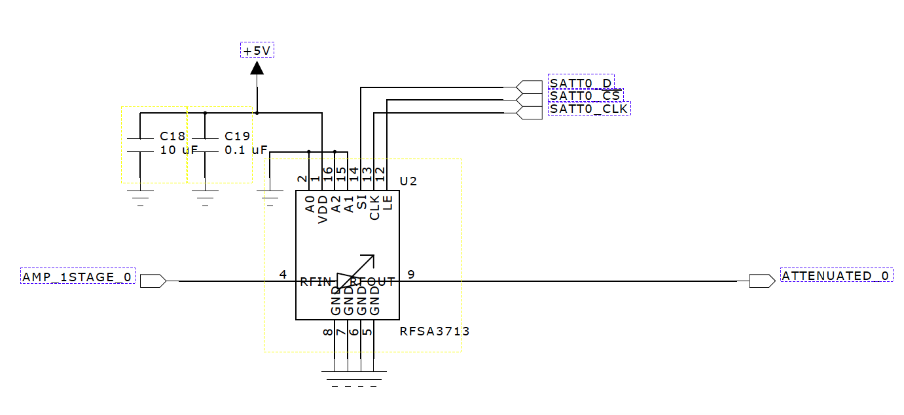

* Pin legend for the attenuator (from data sheet)

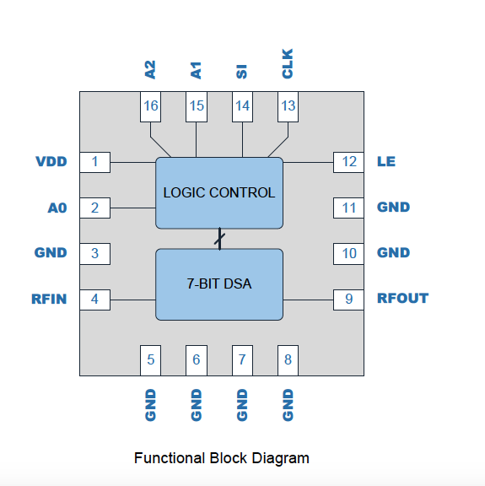

* The Microcontroller pin legend (from data sheet)

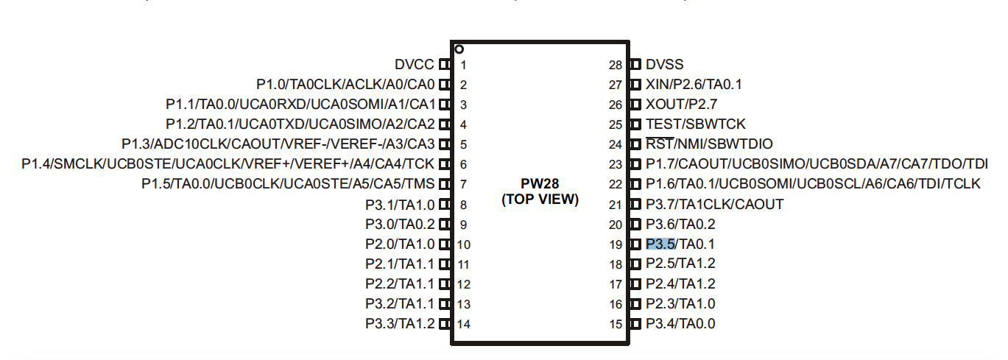

* The microcontroller pin assignments (from PC schematic)

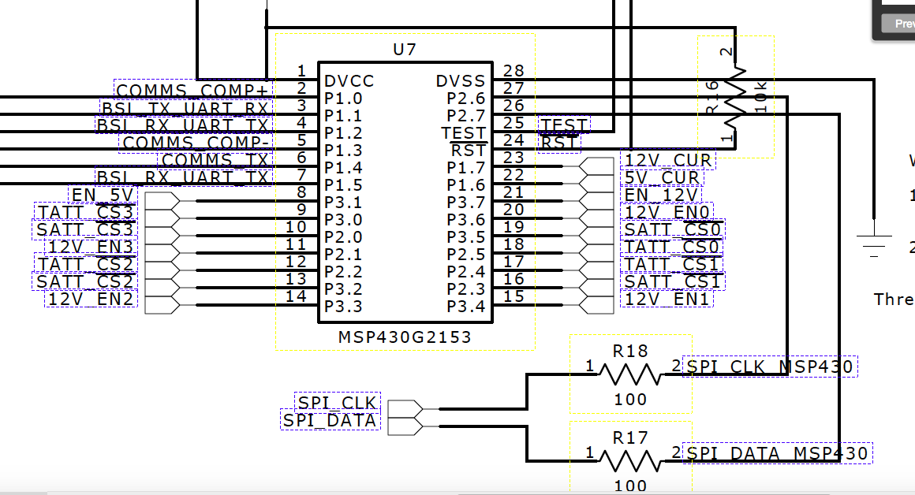

* The Microcontroller connectivity (PC schematic)

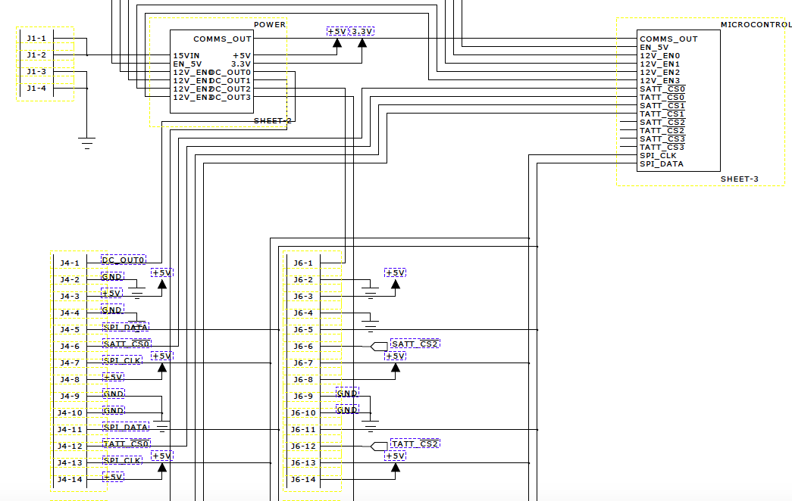

* The Microcontroller connectivity (RF schematic)

